🡪mysql -u root -p

🡪Root123$

🡪show databases;

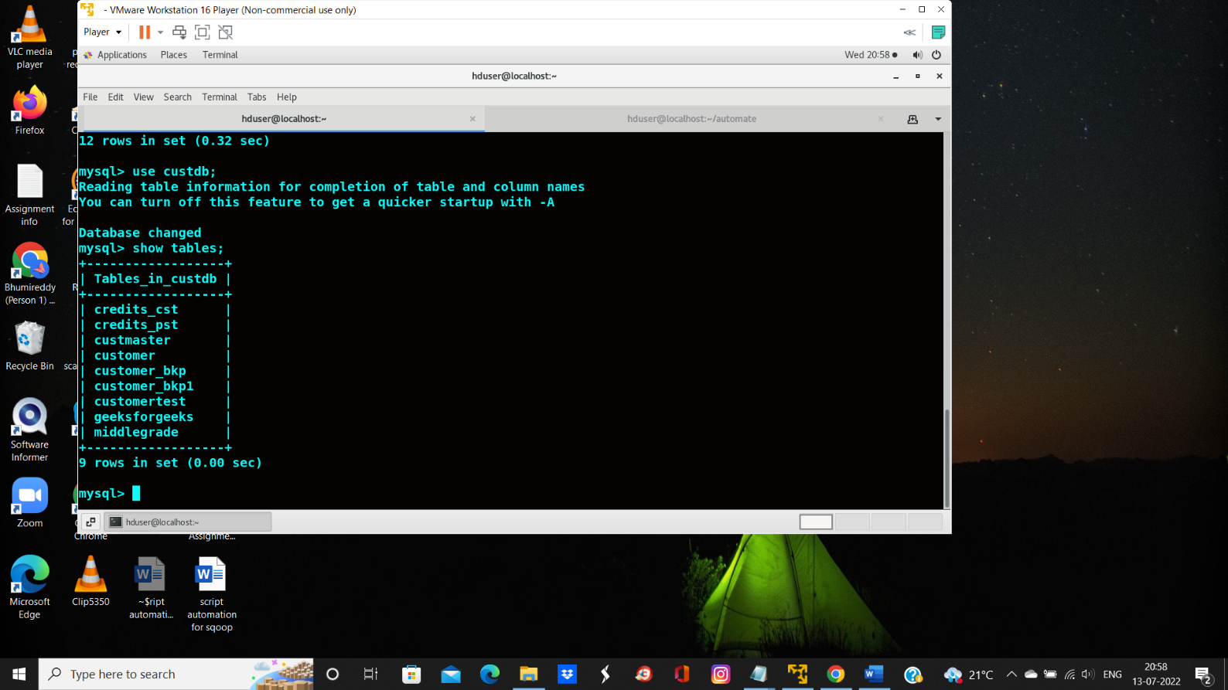

🡪open other terminal

🡪mkdir automate

🡪ls //to see directories

🡪cd automate

🡪pwd //to see path

/home/hduser/automate

🡪gedit table_name.txt

🡪gedit properties.config

🡪gedit main.sh

